**2014**

Alonso Jiménez, Pedro Andrés García, Sergio Andrés Sanmiguel, Agustín De Miguel Pérez, Beatriz García Pérez, Juan Manuel. Guerrero Santana, Esther Salcedo Ortíz, Marloon Soria Gallego, Juan

Accenture

12/3/2014



WEB APPLICATION USER GUIDE

Contents

1. INTRODUCTION 2

2. LEVEL ACCESS 2

3. DESCRIPTION OF OPERATION 2

3.1. LOGIN 2

3.2. NEW USER REGISTRATION 3

3.3. HOME PAGE FROM ADMIN 5

3.4. PROFILE 6

# INTRODUCTION

New Coddington is a city with two areas, north and south, with different activities in each area. This application facilitates the registrarion of different events in different places.

Access to the application is made by using a Web browser.

This application is compatible with Internet Explorer Mozilla Firefox and Google Chrome, but the best browser to use New Codington Web is Google Chrome.

# LEVEL ACCESS

|  |  |  |
| --- | --- | --- |
| LEVEL ACCESS | VIEWING OF CONTENTS | MAINTENANCE BASE TABLES |
| ADMIN | x | x |
| VISITOR (USER BASIC) | x |  |

# DESCRIPTION OF OPERATION

## LOGIN

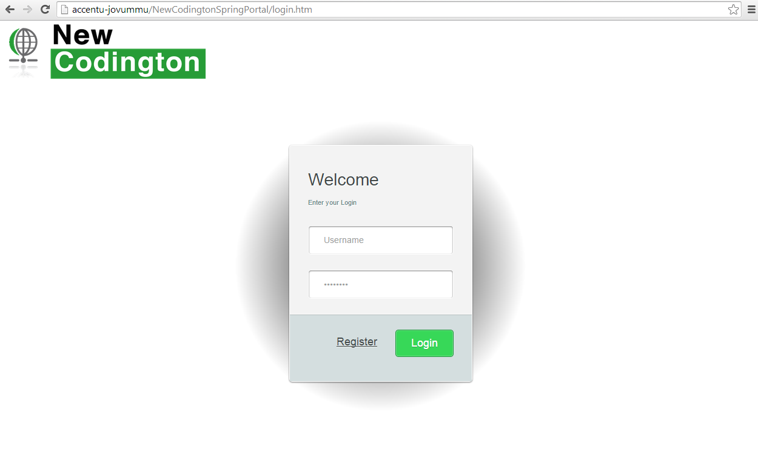

Users who have previously registered for the New Codington Web Application must login by:

* Entering their **User Name**.
* Entering their **Password**.
* Selecting button **Login** to advance to the next screen and begin using the application.

**Site Registration**

Users who have not previously registered for the New Codington Web Application must select “Register” to access the “New User Registration” page.

## NEW USER REGISTRATION

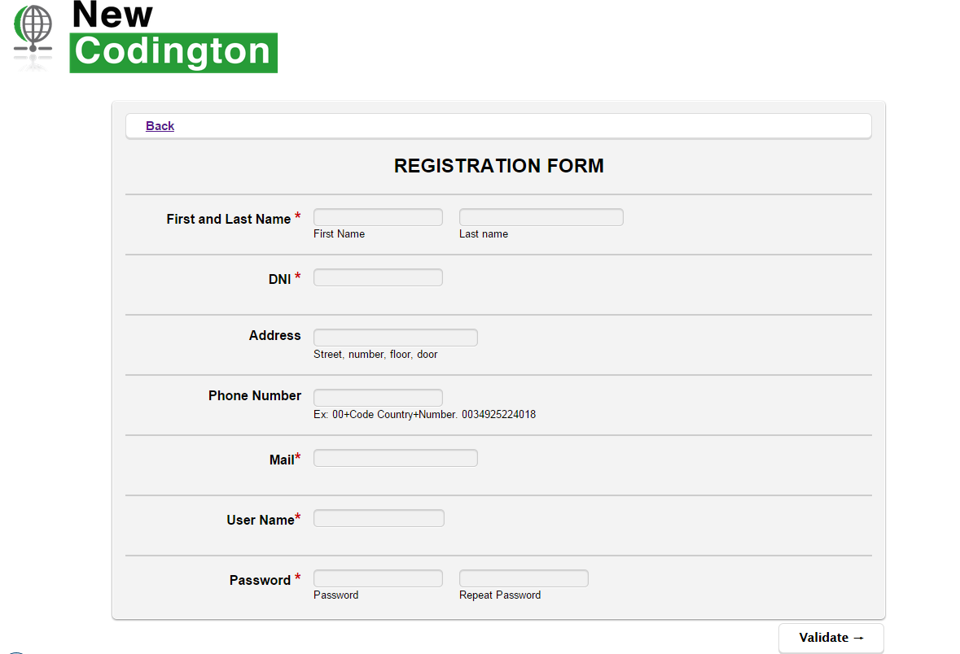

Users will be asked to enter or select the following information:

**Name — First and Last**

Enter the user’s first and last name.

**DNI**

Enter the user’s identifier document

**Address**

Enter the user’s address.

**Phone Number**

Enter the user’s telephone number, including extension.

**E-Mail**

Enter the user’s e-mail address.

**Confirm E-Mail**

The e-mail address entered in this field must match the address entered in the “E-mail” field.

**User Name**

User names must be at least six characters long and can be alphanumeric (e.g., abcd123). Each user is required to select a unique user name and password.

**Password**

Passwords must be at least eight characters long.

**Repeat Password**

The password entered in this field must match the password entered in the “Password” field.

**Validation**

Select "Validation" to submit the registration information and continue to the next screen.

**Back**

Select "Back" to back to previous page.

HOME PAGE FROM VISITOR

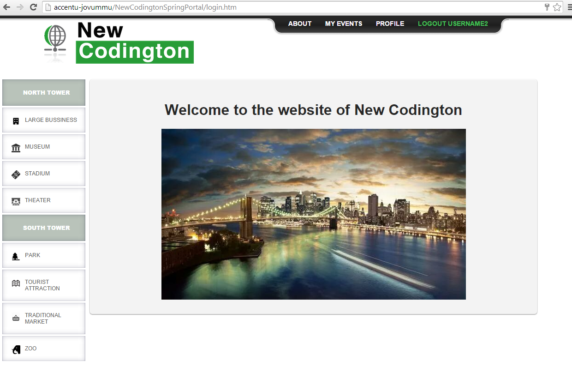

After logging into the New Codington Web Application, the user will advance to the New Codington Home Page. Select the buttons on the left side of this page to do the following:

* **View north places** —Visitor may select from this list the places to display the events
* **View south places** — Visitor may select from this list the places to display the events

Select the buttons on the top side of this page to do the following:

* **Logout** — Visitor are suggested to logout of the New Codington Web site, when finished, by selecting the “Logout” button at the top of the application or closing their browser.
* **About** — Visitor may view information about New Codington Web.
* **Update User Profile** — Visitor may modify their personal profile information (e.g., name, address, or telephone number).
* **My Events** — Visitor may view their events in which is registered.

To come home, the visitor must be click on the image “NEW CONDINGTON”.

## HOME PAGE FROM ADMIN

After logging into the New Codington Web Application, the user will advance to the New Codington Home Page. Select the buttons on the left side of this page to do the following:

* **View north places** —Visitor may select from this list the places to display the events
* **View south places** — Visitor may select from this list the places to display the events

Select the buttons on the top side of this page to do the following:

* **Logout** — Admin are suggested to logout of the New Codington Web site, when finished, by selecting the “Logout”button at the top of the application or closing their browser.
* **About** — Visitor may view information about New Codington Web.
* **Update User Profile** — Visitor may modify their personal profile information (e.g., name, address, or telephone number).
* **Add Event** — Admin may add events.
* **Add Place** — Admin may add places.

Note: To update and delete events and places, admin have to go to the menu on the left.

If admin want to delete or update a place, have to go to the menu on the left and select the place.

If admin want to delete or update an event, have to go to the menu on the left, select the place and select an event to do any of those things

To come home, admin must be click on the image “NEW CONDINGTON”.

## **PROFILE**

The following fields can be modified if the user needs to update his or her user profile:

*Note:* User Name is the only field that cannot be changed in this page

**Name — First and Last**

Enter the user’s first and last name.

**DNI**

Enter the user’s identifier document

**Address**

Enter the user’s address.

**Phone Number**

Enter the user’s telephone number, including extension.

**E-Mail**

Enter the user’s e-mail address.